**Ideation Phase**

**Brainstorm & Idea Prioritization Template**

|  |  |
| --- | --- |
| Date | 25 june 2025 |
| Team ID | Team ID: LTVIP2025TMID31490 |
| Project Name | Health AI:Intelligent healthcare assistant |
| Maximum Marks | 4 Marks |

**Brainstorm & Idea Prioritization Template:**

Great! Let’s walk through the Brainstorming and Idea Development phase based on your IBM Granite-based Health Assistant code.

🎯 Project Idea:

Build an AI-powered Intelligent Healthcare Assistant that uses IBM Granite LLM to analyze patient symptoms and suggest possible health conditions.

---

✅ Problem Statement:

Patients, especially in remote areas or during off-hours, often lack access to immediate medical guidance. There's a need for an intelligent assistant that can:

Collect symptoms

Analyze them with AI

Offer non-diagnostic, suggestive health insights

---

🤔 Brainstormed Features:

Feature Idea Why It’s Useful

🔹 Symptom Input Interface To allow users to describe issues easily via natural language

🔹 AI Analysis via IBM Granite Uses a powerful LLM to generate suggestive conditions from symptoms

🔹 Timestamp Logging Useful for tracking or auditing conversations

🔹 Friendly Conversational Output Makes interaction simple and human-like

🔹 Warning About Non-Diagnosis Ensures ethical use (not replacing a real doctor)

---

🔄 Brainstorm Enhancements:

Idea Impact

Add voice input using speech_recognition More accessible and hands-free

Connect to EMR or wearable data Gives more accurate suggestions

Add emergency contact alert feature Safety feature for critical cases

Build chatbot UI with Flask/Streamlit Move from CLI to web/mobile access

Include multi-language support Wider user base (non-English users)

---

🧠 Technologies Considered (during brainstorming):

LLM: IBM Granite (chosen), GPT-4 (alternative)

Frontend: CLI (current), Flask or Streamlit (planned)

Storage: SQLite or file logging (optional extension)

APIs: Integration with MedlinePlus or Mayo Clinic APIs (for verified info)

--

Reference: <https://www.mural.co/templates/brainstorm-and-idea-prioritization>

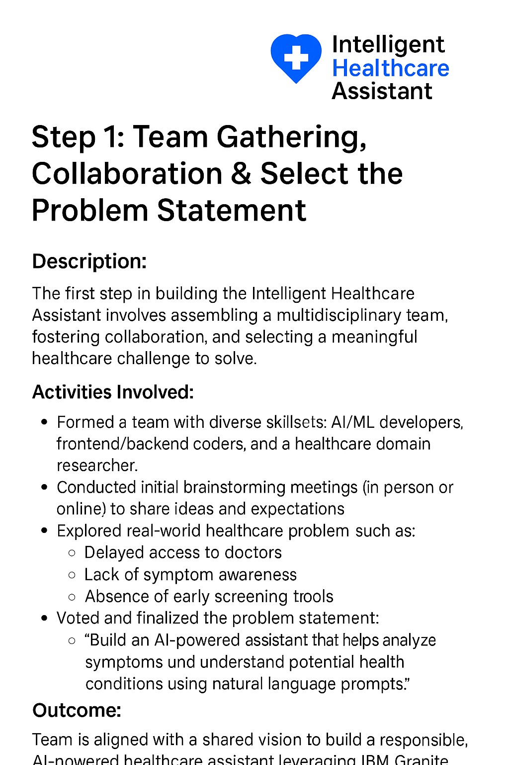

**Step-2: Brainstorm, Idea Listing and Grouping**

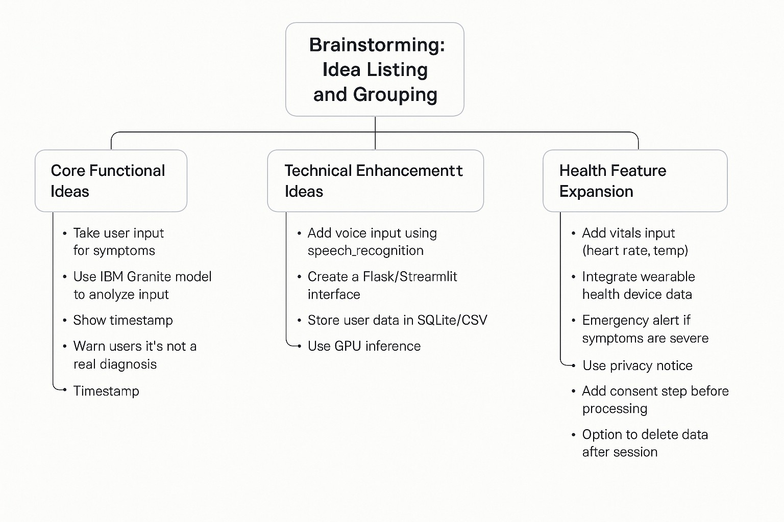

**Step-3: Idea Prioritization**

